Maze Game Documentation

Language choice: Python

Modules used: Pygame

Design

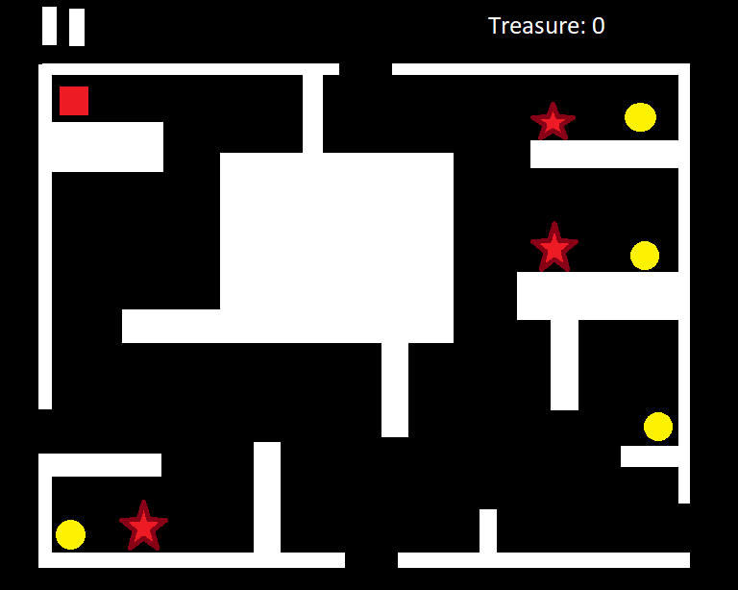

Errors